Jahresbericht
C. Cozzo, Schach

After the change in lead of the section (R. Mukin left PSI) and the pandemic situation finally coming to an end, in 2022 the chess activities have resumed:
- Chess evening are typically taking place on the last Tuesday of the month.
- The website has been updated.
- There are currently 15 registered members in the section, 2 of them former PSI colleagues.
- A tournament has been organised at the PSI Sportclub Fest. 8 participants have registered. A prize has been given to the winner Umut Sanli, who left PSI at the end of 2022.
- Another tournament is being prepared for the beginning of 2023. As of 18.01.2023, 7 people have registered. (Update: the tournament has started, 12 players are registered)
Budget:
- For tournament prize and acquisition of 2 chess boards, approx. 100 CHF have been spent by the section in 2022.
- For 2023, a budget of 200 CHF is foreseen that will allow the acquisition of 2 chess clocks and a prize for a tournament.

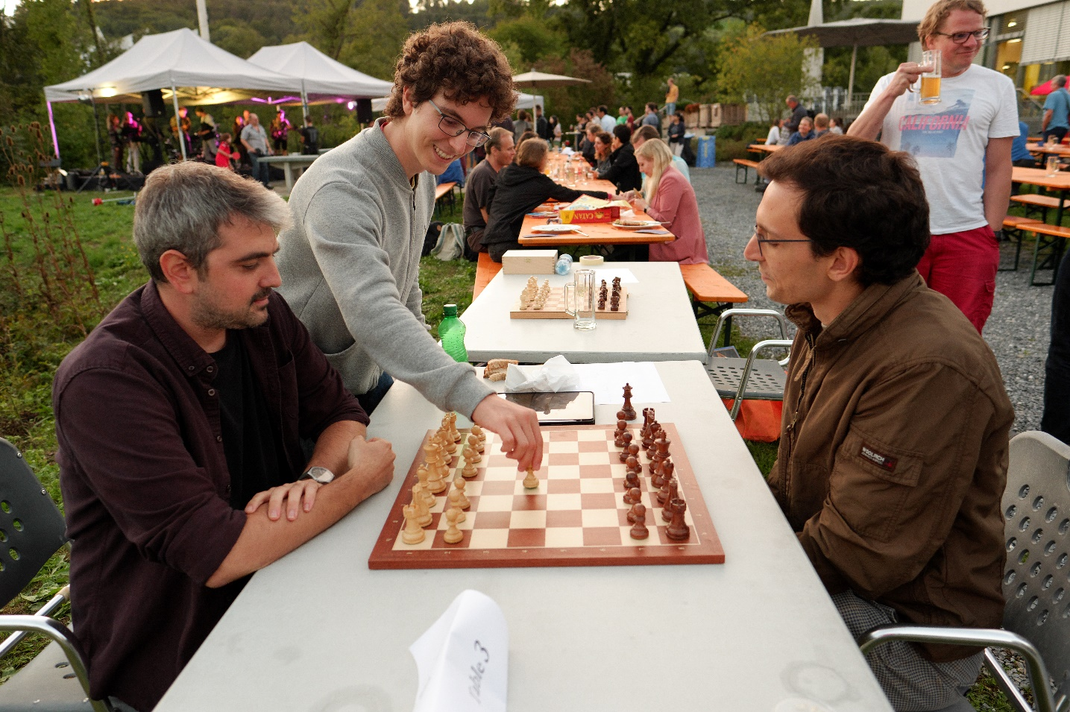Picture: Opening of a game in the Blitz tournament during the PSI Sportclub Fest 2022.

